Software Requirement Specifications
Gym management system


Submitted By
Name: Muhammad Abdullah
Roll No: S23BSEEN1M01073

Supervised By
Prof. Sir Zaman Ali
Department of Information Technology
Faculty of Computing
The Islamia University of Bahawalpur

Summary
The Gym Management System is a comprehensive software solution to streamline gym operations, including member registration, class scheduling, and staff management. It automates tasks like billing, payments, and attendance tracking while offering user-friendly interfaces for members and staff. The system provides analytics and reports for business insights and supports notifications for dues, classes, and promotions. With secure payment integration and cloud storage, it ensures efficiency and data safety. This tool enhances member engagement and simplifies management for gym owners.

Table of Content
1. Introduction 1
1.1 Purpose 1
1.2 Scope 1
1.3 Product Perspective 1
1.4 User Characteristics 2
1.5 Similar Apps and Systems/Literature Review 2
1.6 Proposed Technologies 3
2. Requirements 4
2.1 Functional Requirements 4
2.2 Non-Functional Requirements 5
3. Use Cases and Flow of Processes 6.
4 4. References 7.

1. Introduction

The Gym Management System is a software designed to optimize the operations of fitness centers and gyms. It manages memberships, schedules classes, tracks attendance, and handles billing and payments. The system provides an easy-to-use interface for members and staff while offering detailed reports and analytics for administrators. With features like notifications and secure payment integration, it ensures a seamless experience for all users. This solution enhances efficiency, reduces manual tasks, and improves overall gym management

1.1 Purpose

The purpose of this document is to define the functional, non-functional, and system requirements for the Gym Management System. The system will streamline gym operations, manage memberships, schedules, billing, and staff, and provide a better experience for gym members and administrators.

1.2 Scope
The Gym Management System will:
- Manage member registration, subscriptions, and attendance.
- Handle scheduling for trainers, classes, and equipment usage.
- Automate billing and payment tracking.
- Generate reports for business insights (e.g., revenue, member attendance).
- Provide a user-friendly portal for members and staff.

Definitions, Acronyms, and Abbreviations
- SRS: Software Requirements Specification
- Admin: Gym owner/manager who oversees operations.
- Member: Gym customer with a subscription plan.

1.3 Product Perspective

The system is a standalone web and mobile application designed to improve operational efficiency and member satisfaction. It integrates with payment gateways and communication tools like email and SMS.

Product Features
- Member Management
- Staff Management
- Scheduling and Class Management
- Billing and Payment Tracking
- Reporting and Analytics
- Notifications and Alerts
- Access Control via Role-Based Permissions

1.4 User Classes and Characteristics
• Admins: Manage gym operations, staff, and finances.
• Trainers: Access schedules and manage their assigned classes.

• Members: View personal schedules, pay bills, and track progress.

Operating Environment
- Web and mobile (Android/iOS) platforms.
- Compatible with modern browsers and devices.

Design and Implementation Constraints
- Integration with payment gateways (e.g., Stripe, PayPal).
- Must comply with data privacy regulations (e.g., GDPR).

Assumptions and Dependencies
- Internet connectivity is required for real-time operations.
- Admins and staff will undergo training to use the system.

1.5 Similar Apps and Systems

• Mindbody
- A popular fitness and wellness management software for gyms, yoga studios, and personal trainers.
- Key Features: Member registration, online scheduling, mobile app, payment processing, and marketing tools.
- Relevance: Demonstrates a robust platform with focus on customer engagement and scalability.

• Glofox
- Designed specifically for fitness businesses to manage operations and grow memberships.
- Key Features: Member app, class scheduling, membership management, and payment integrations.
- Relevance: Emphasizes a user-friendly interface and mobile-first approach.

1.6 Proposed Technologies
- Frontend: PhP or React.js
- Backend: Node.js or Django
- Database: MySQL
- Authentication: OAuth 2.0

2. Requirements

2.1 Functional Requirements

Member Management
- Register and update member profiles.
- Track membership plans, payments, and attendance.

Staff Management
- Manage staff profiles, roles, and schedules.
- Assign trainers to specific classes or members.

Class and Scheduling Management
- Create, update, and manage class schedules.
- Allow members to book or cancel classes.

Billing and Payments
- Generate invoices for membership fees and services.
- Accept payments via credit/debit cards, e-wallets, and bank transfers.
- Send reminders for due payments.

Reporting and Analytics
- Generate reports for revenue, attendance, and member activity.
- Export reports in CSV or PDF format.

Notifications and Alerts
- Notify members about upcoming classes, dues, or special offers.
- Send alerts for expiring memberships.

2.2 Non-Functional Requirements

Performance Requirements
- System should handle 1000 concurrent users without performance degradation.
- Response time for actions should not exceed 3 seconds.

Security Requirements
- Use role-based access control (RBAC) to restrict system access.
- Encrypt sensitive data (e.g., passwords, payment details).

Usability Requirements
- Intuitive interface for members and staff.
- Provide multi-language support.

Reliability Requirements
- System uptime of 99.9%.
- Data backups performed daily.

3. System Models

Use Case Diagram
Show how Admins, Trainers, and Members interact with the system.

Class Diagram
Illustrate the relationship between system entities like Members, Staff, Casses,and Payments.

Sequence Diagram
Detail workflows, e.g., member registration and payment processes.

3.1. Use Cases and Flow of Processes
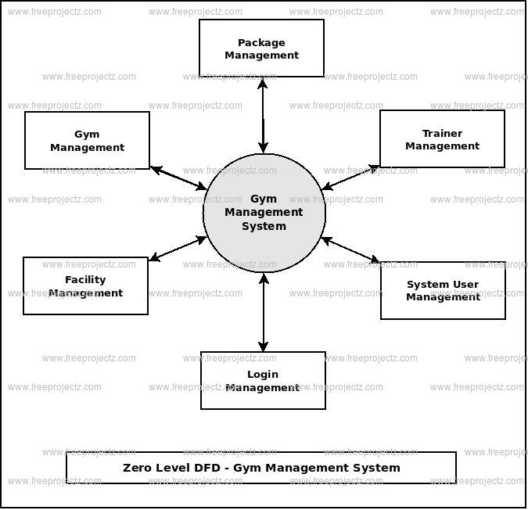

4. Appendices
- List any additional information or technical details.
- Glossary of terms.

5. References
- Hoffer, J. A., Ramesh, V., & Topi, H. (2016). Modern Database Management (12th ed.). Pearson.
- Sommerville, I. (2016). Software Engineering (10th ed.). Pearson.
- Mindbody Inc. (n.d.). "Features and Capabilities." https://www.mindbodyonline.com.
- Glofox. (2023). "Gym Management System Features." Retrieved from https://www.glofox.com.
- IEEE Standards Association. (1998). "IEEE Recommended Practice for Software Requirements Specifications." IEEE Std 830-1998. https://standards.ieee.org.
- Firebase Documentation. (n.d.). "Firebase: A Comprehensive Overview." https://firebase.google.com/docs
- React.js Official Documentation

